A/T FLUID REPLACEMENT

caution | Before replacing the transmission with a new one, overhauling the existing transmission, or connecting the cooler pipe to the transmission, the A/T fluid cooler line should always be flushed out.

In you have an A/T fluid changer, use the A/T fluid changer to flush the A/T fluid. If you do not have an A/T fluid changer, follow the procedure given below.

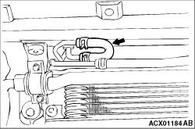 | 1.Remove the hose shown in the illustration which allows the A/T fluid to flow from the A/T fluid cooler to the transmission.  2.  Start the engine and discharge the A/T fluid.  Driving conditions: N range, idling  Discharge amount: Approx. 3.5 L
  caution | The engine should be stopped within one minute of it being started. If the A/T fluid has all been discharged before this, stop the engine at that point.

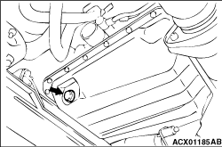 | 3.Remove the drain plug at the bottom of the transmission case to drain out the remaining A/T fluid.  Discharge amount: Approx. 2.0 L  4.Install the drain plug with a gasket in between, and tighten it to the specified torque.  Tightening torque: 32 ± 2 N·m  5.  Pour the new A/T fluid in through the oil filler tube.  Amount to add: Approx. 5.5 L  6.Repeat the operation in step 2.  7.Pour in new A/T fluid through the oil filler tube.  Amount to add: Approx. 3.5 L
  caution | Stop pouring in the A/T fluid once 5.5 L has been poured in.
  note | Carry out steps 2 and 7 so that at least 8.0 L has been discharged from the cooler hose. After this, discharge a small quantity of A/T fluid and check for contamination. If the A/T fluid is contaminated, repeat steps 6 and 7.

8.Connect the hose which was disconnected in step 1, and then securely re-insert the oil level gauge.
9.Start the engine, and let it run at idle for 1 - 2 minutes.
10.Move the selector lever to all positions once, and then return it to the N position.

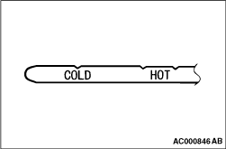 | 11.Check that the A/T fluid level on the oil level gauge is at the COLD mark. if it is not up to this mark, add more A/T fluid.

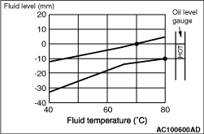 | 12.Drive the vehicle until the A/T fluid temperature reaches the normal temperature (70 - 80°C), and then re check the A/T fluid level.  13.When A/T fluid is under the specified level, top up A/T fluid. When A/T fluid is over the specified level, drain the excessive A/T fluid from the drain plug to adjust A/T fluid level to the specified level.  14.Securely insert the oil level gauge into the oil filler tube.
  note | The COLD mark is for reference only; the HOT marks should be used as the standard for judgment.
  note | A/T fluid temperature using M.U.T.-III.
  note | Check the fluid level referring to the characteristics chart shown if it takes some time until reaching the normal operation temperature of A/T fluid (70 - 80°C.)

