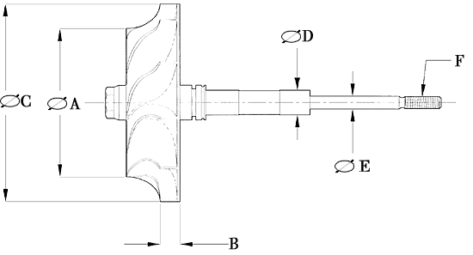

Turbine Wheel / Shaft Data
A | Exducer Diameter | 40.5
B | Tip Height | 7
C | Inducer Diameter | 52
D | Journal Diameter | 9.3
E | Shaft Diameter | 6.1
F | Shaft Thread | 6
 | Number of Blades | 11

D项涡轮轴大经，E项小径,F项锣纹锣距，B项钢轮叶前高,C项钢轮大经,A项钢轮小经
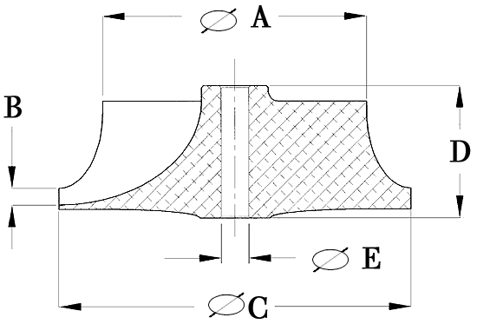

Compressor Wheel Data
A | Inducer Diameter | 35
B | Tip Height | 5
C | Exducer Diameter | 54
D | Hub Length | 24.6
E | Bore Diameter | 6.1
 | No. of Blades | 10
 | Style
叶轮A项叶轮小经 ，B项叶轮叶前高 ,C项大经 ,D项总高 ,E项里空 ,叶片6长6短

